Yo
generate a city landscape with Rembrandt style. The view is from inside a room looking through semi circular windows. Place XVIII century furniture. Decorate walls with Picasso and Dali paintings
ChatGPT
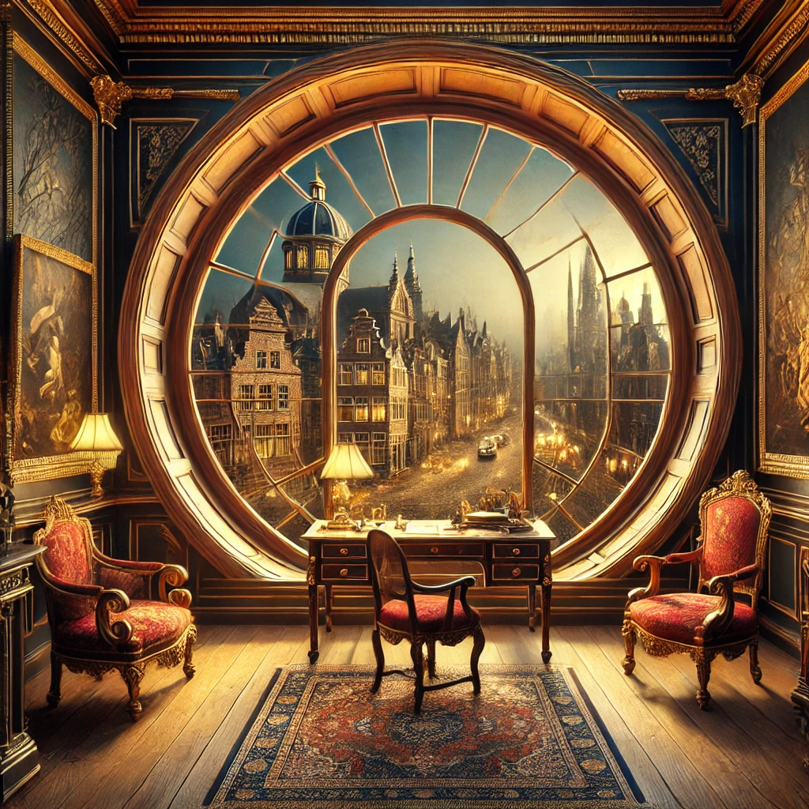
Yo:
generate 3 more

ChatGPT:

Generate another one of a Dali-Style city scape with same description
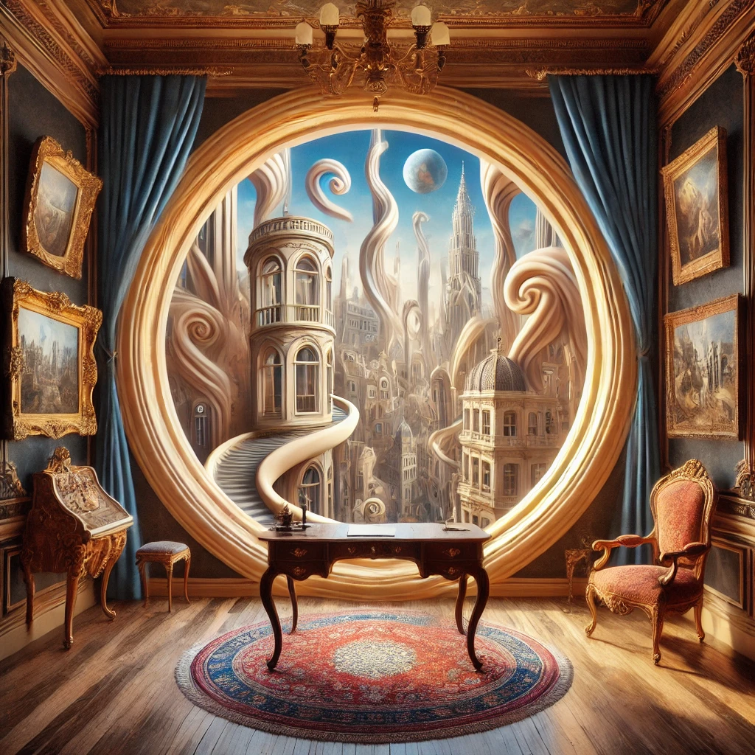
Award winning AI generated image:
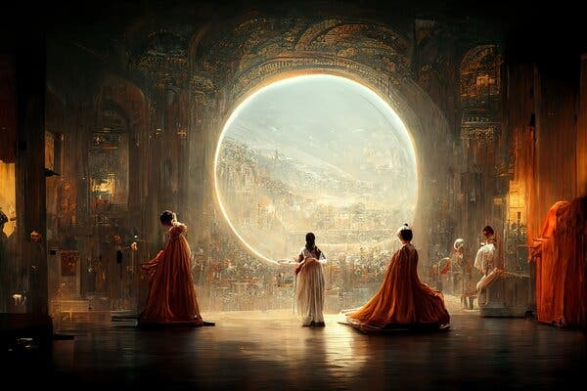

Yo
generate an image that explains long-tailed probability distributions

ChatGPT:
